|  |
| --- |
| Date/Location |
| 04/15/2022 @Zoom, 2:00 – 3:00 PM |

|  |  |
| --- | --- |
| Attendees | |
| Client | MAVDEV |
| Joe Saceric | Ammar Lokhandwala |
| Umera Khan | Maria Frausto |
|  | Michael Gurch |
|  | Victoria Sheraden |
|  | Vivian Bui |

|  |
| --- |
| Meeting Agenda |

1. **Current Trello Board**

For Meetings:

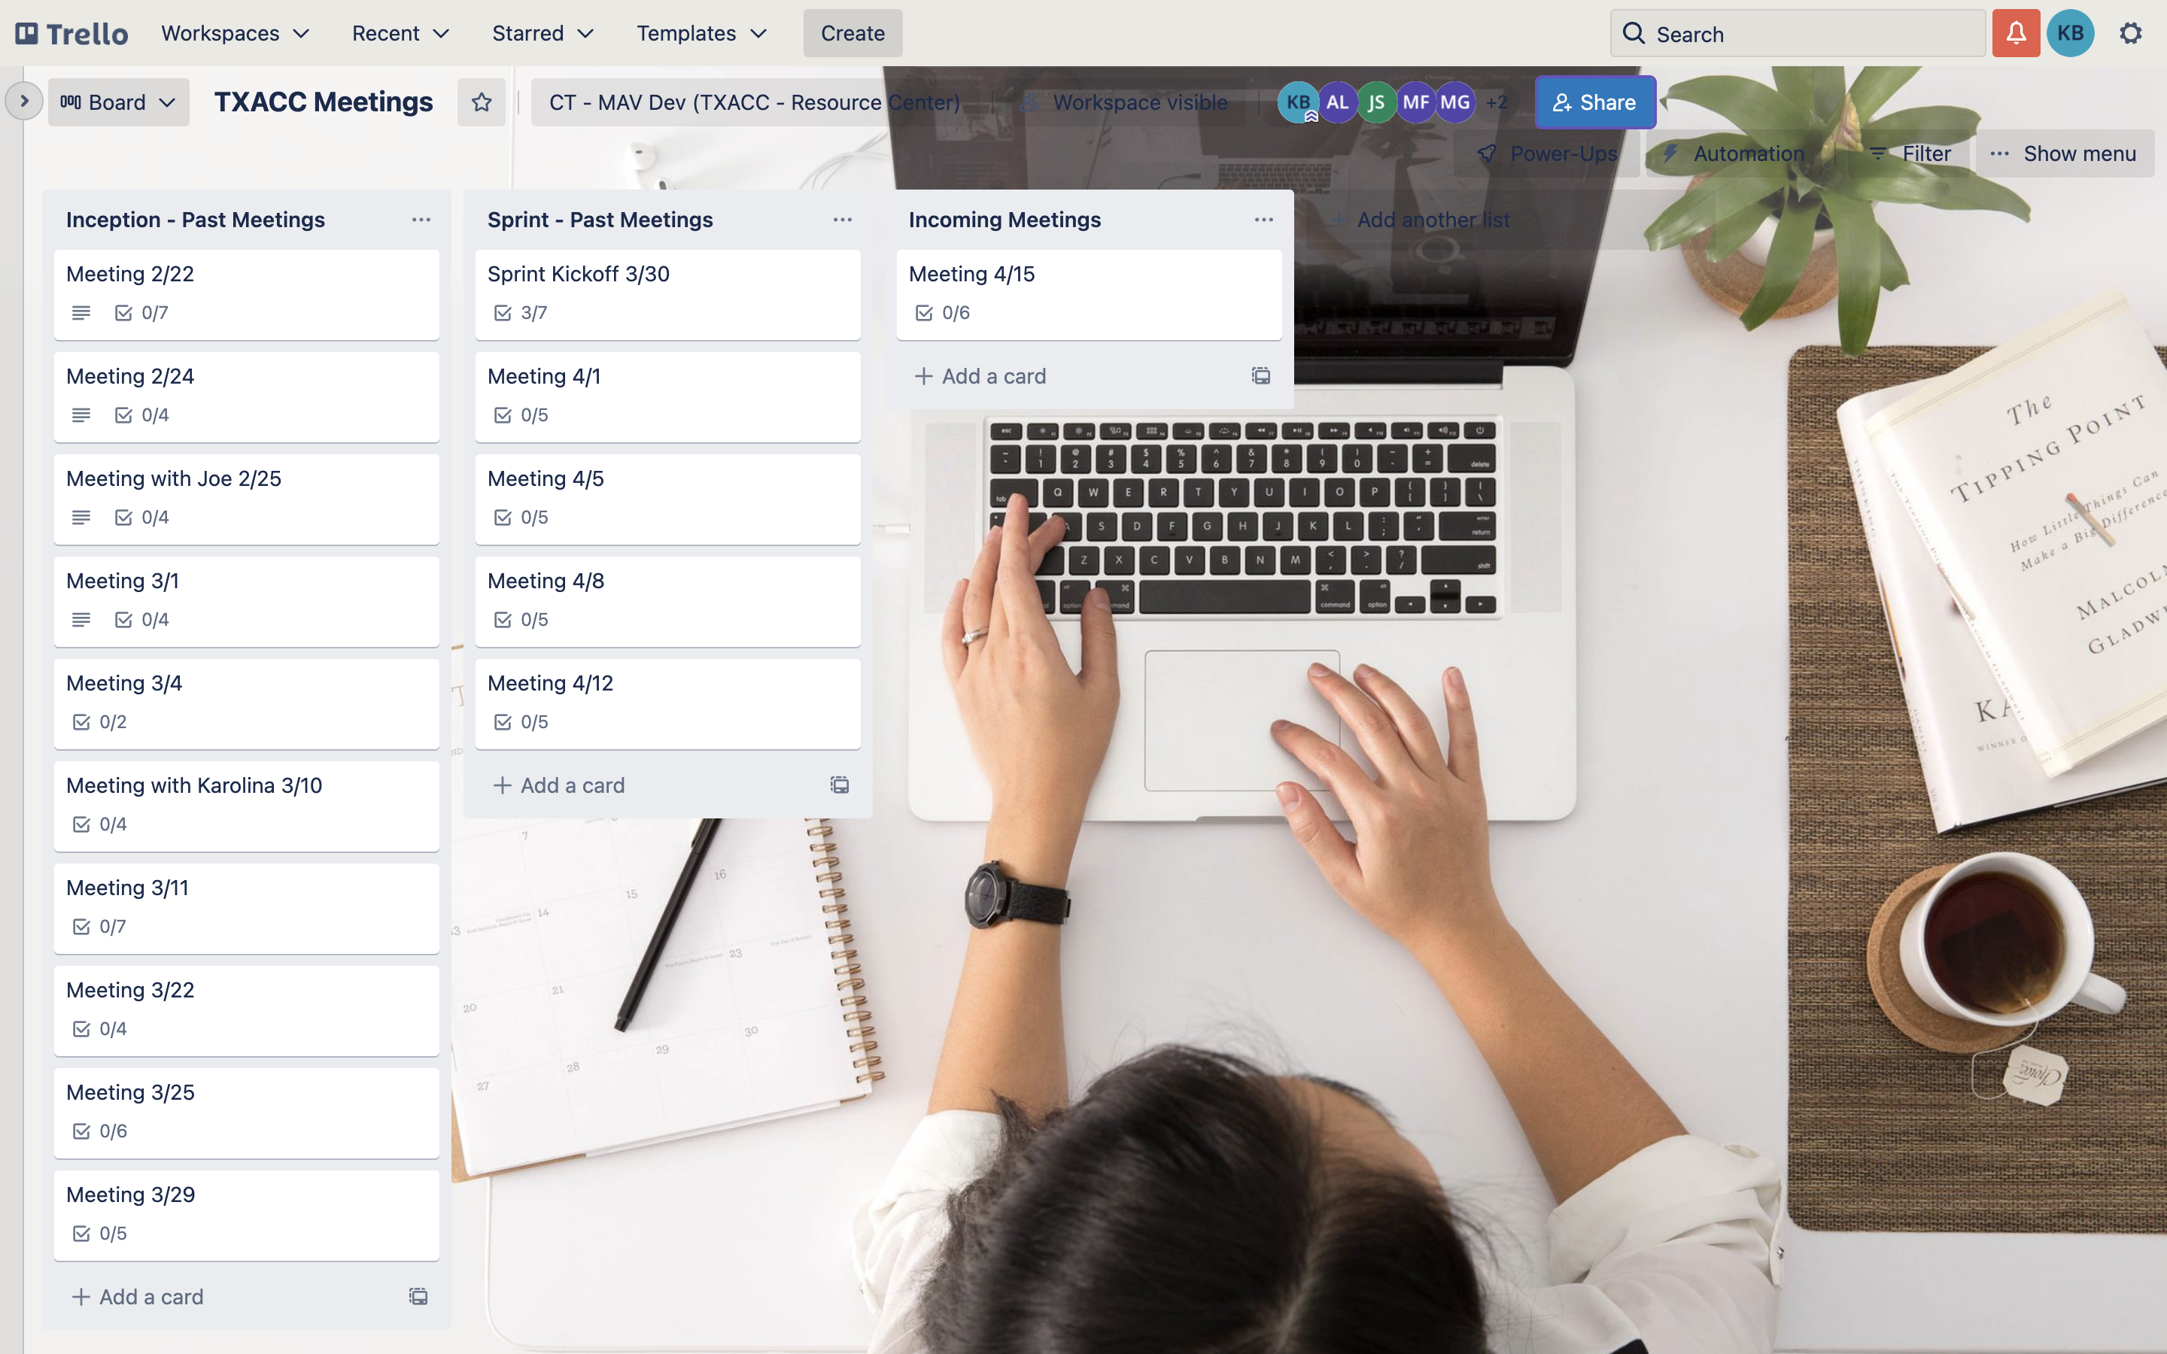

For Development:

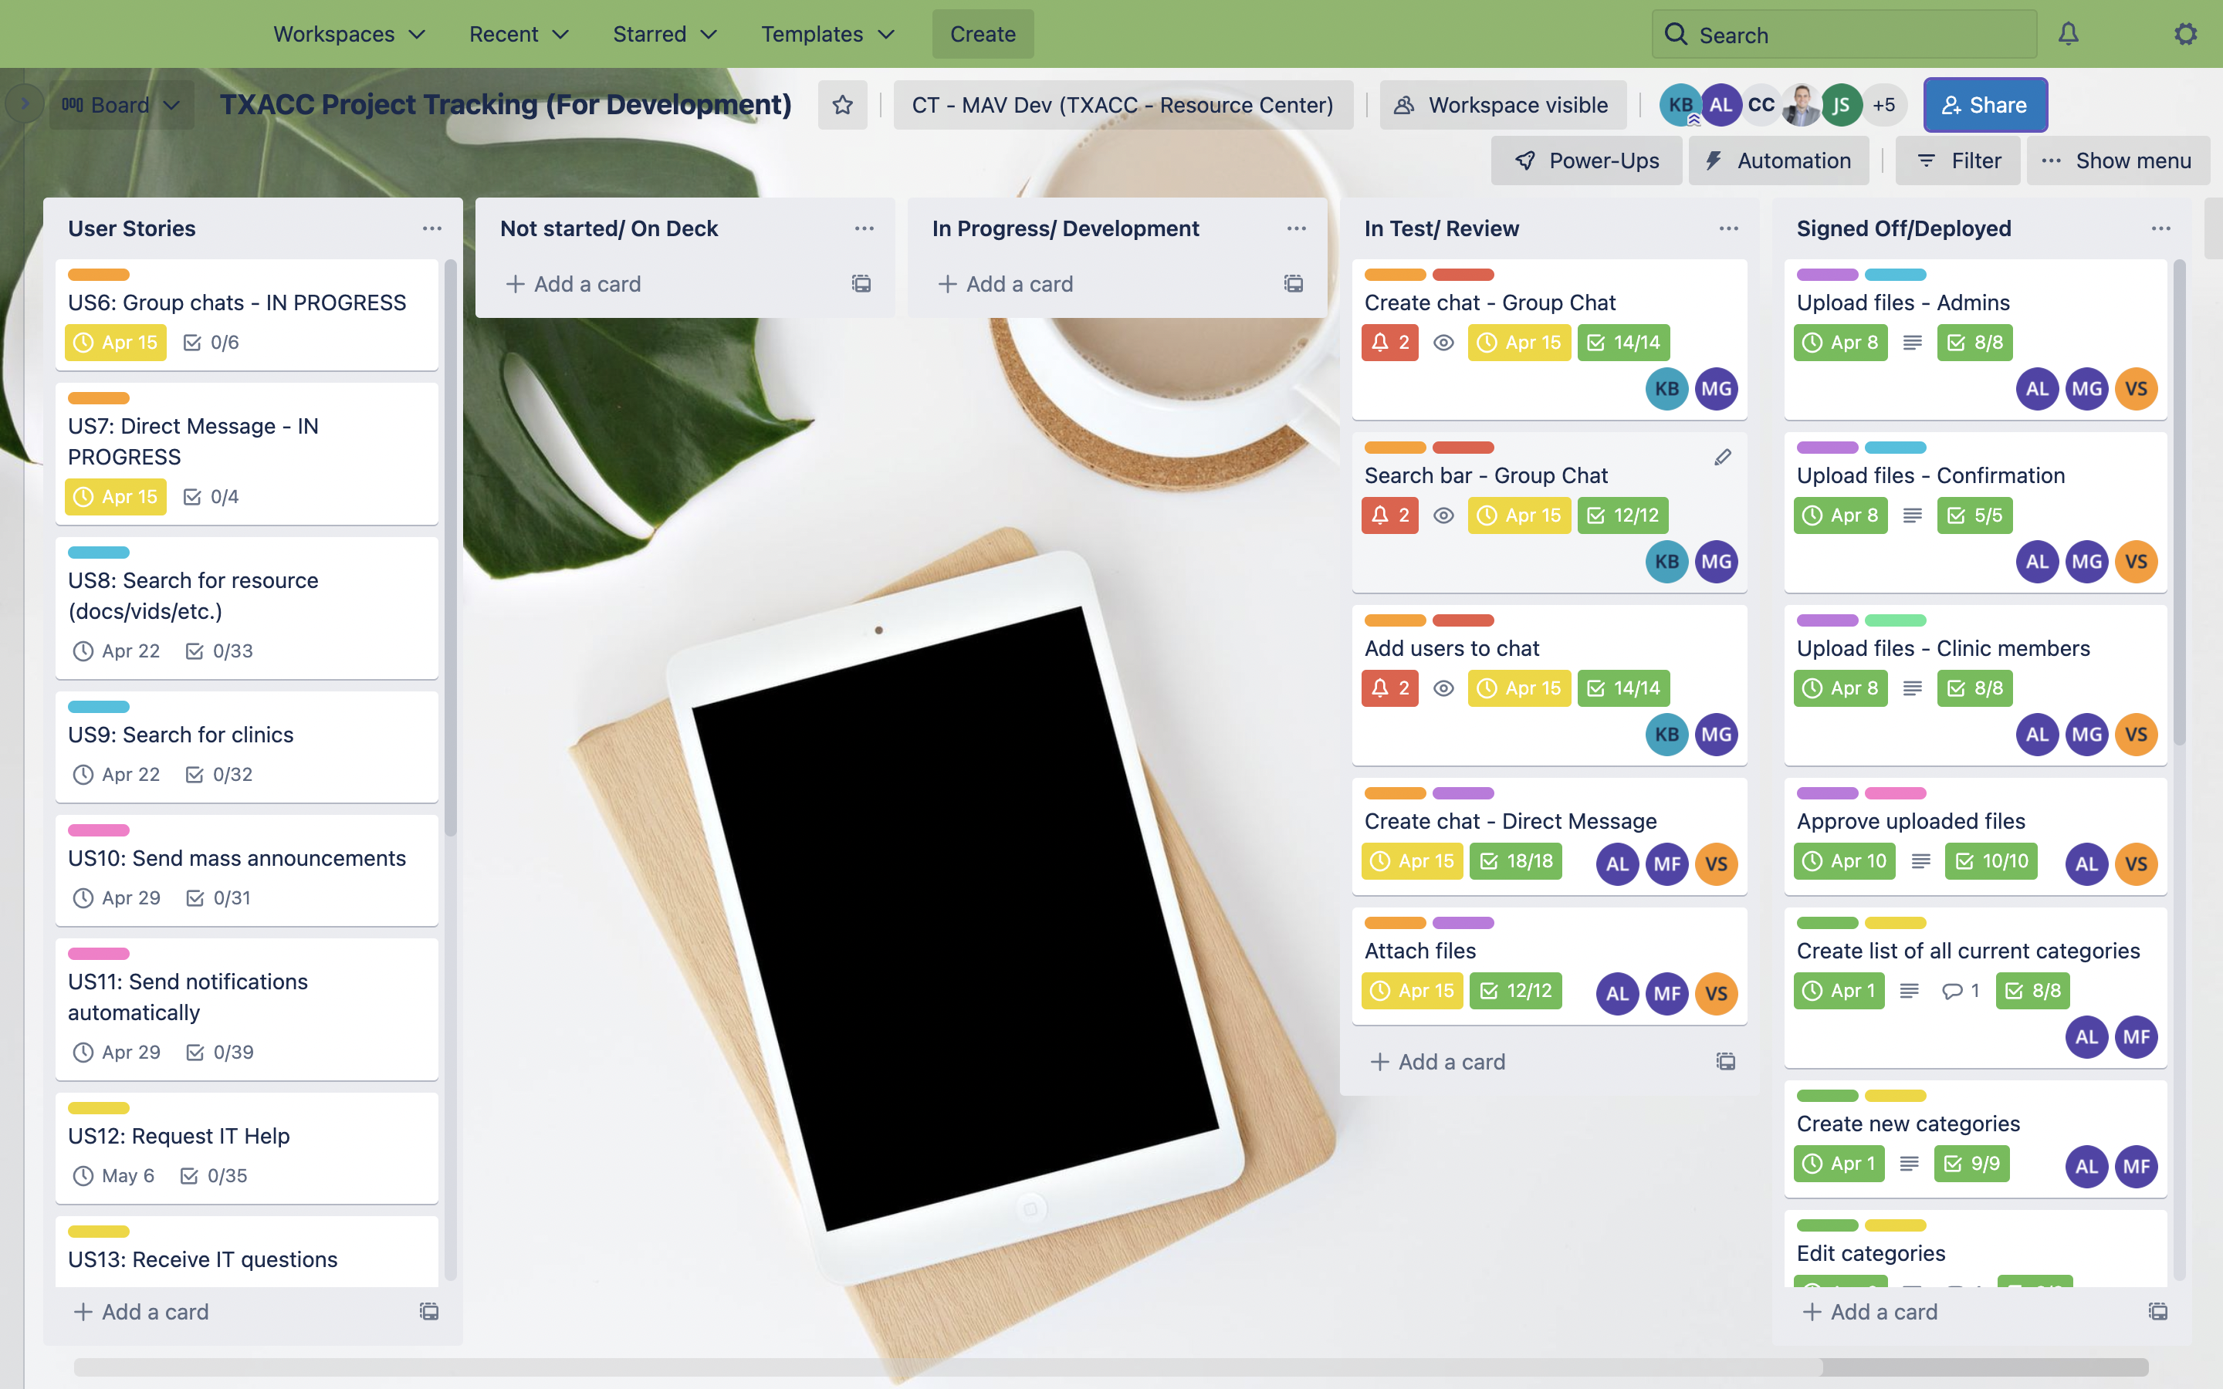

1. **Discussion Agenda**

* UAT Feedback
* Training
* Sign-off Trello
* UI/UX: Review landing page
* UI/UX Documentation updated
* Confirm US for Sprint 4